FREELANCE PLATFORM FOR

DIGITAL ARTS

A PROJECT REPORT PRESENTED BY

H.D.T. HAPANGMA

(S/17/522)

to the Board of Study in

**DEPARTMENT OF STATISTICS AND COMPUTER SCIENCE**

*in partial fulfillment of the requirement*

*for the award of the degree of*

**B.Sc. in Computer Science**

of the

**UNIVERSITY OF PERADENIYA**

**SRI LANKA**

**2023**

# DECLARATION

I do hereby declare that the work reported in this project report was exclusively carried out by me under the supervision of Mr. Prabhath Gunathilaka. It describes the results of my own independent work except where due reference has been made in the text. No part of this project report has been submitted earlier or concurrently for the same or any other degree.

Date: ……………………. ……………………………………………………….

Signature of the Candidate

Certified by:

Supervisor (Name): Mr. Prabhath Gunathilaka. Date: ………………………...

Signature: …………………………………………

**Department Stamp:**

# DEVELOPMENT OF THE FREELANCE DIGITAL ART PLATFORM

**H.D.T.HAPANGMA (S/17/522)**

Department of Statistics and Computer Science University of Peradeniya, Peradeniya, Sri Lanka

The world has become increasingly interconnected, with businesses and individuals across the globe seeking digital solutions to communicate and collaborate with each other. However, the communication barriers presented by different languages, cultures, and time zones can often hinder effective communication and collaboration. This is especially true for the freelance industry, where communication is essential for delivering high-quality products that meet the needs of clients.To address this problem, the IDILIO platform offers an all-in-one solution that connects service providers with professional-level buyers from all over the world. Through IDILIO, freelancers can offer high-quality digital products that are customized to the preferences of buyers without charging any additional fees. Furthermore, IDILIO's expert design team and user-friendly interface make it easy for freelancers to communicate with buyers from different languages, cultures, and time zones, ensuring that projects are completed efficiently and effectively. By providing a free, accessible, and all-in-one platform that addresses the communication barriers of the freelance industry, IDILIO seeks to empower talented freelancers in Sri Lanka and beyond while contributing to the country's economy through international buyers. With IDILIO, the freelance industry can thrive, and businesses and individuals can enjoy high-quality digital products that meet their needs and preferences, regardless of their location or background.

# Acknowledgments

I would like to express my special thanks to the lecturer and advisor of the CS304- individual project, Dr. Erunika Dayaratna, for his encouragement, continuous guidance, and support throughout the year. Next, I want to express my gratitude to the lecturer of the Department of Statistics and Computer Science, Mr. Prabhath Gunathilaka, for standing up for me in all my failures and guiding me on the right path to solve the problems.

Further, it’s with great pleasure that I acknowledge the staff members of the Department of Statistics and Computer Science for their valuable guidance and support throughout the year, and all at the University of Peradeniya for giving me this valuable opportunity to touch on this kind of essential, practically based area for building up my career ahead.

Finally, thank you, my fellow companies, for helping me throughout the year by sharing ideas and for the support rendered in various situations where I faced difficulties, and to all those who` supported me at least by a word in various ways.

# **TABLE OF CONTENTS**

DECLARATION ii

DEVELOPMENT OF THE FREELANCE DIGITAL ART PLATFORM iii

ACKNOWLEDGMENTS iv

TABLE OF CONTENTS v

LIST OF FIGURES vii

CHAPTER 1: INTRODUCTION 1

1.1 Objectives 2

1.2 Proposed System 2

1.2.1 Advantages of the Proposed System 3

1.2.2 Limitations of the Proposed System 3

1.2.3 Scope of Study 4

CHAPTER 2: LITERATURE REVIEW 5

2.1 Existing Applications 5

2.1.1 Existing Applications Dashboards 6

2.1.1.1 Pros of Existing Systems 7

2.1.1.2 Cons of Existing System 7

2.1.1.3 Pros of the Proposed System Over Existing System 8

CHAPTER 3: METHODOLOGY 9

3.1 Overview of the Proposed System 9

3.2 Requirement Analysis 9

3.2.1 Requirement Of The System 9

3.2.1.1 Software Requirement Specification 9

3.2.1.1.2 Non-Functional Requirements 11

3.2.2 Use Case 12

3.3 Design 13

3.3.1 Entity Relationship Diagram 13

3.3.2 Domain Modeling 14

3.3.2.1 Class Diagram 14

3.4 System Modules 15

3.5 Tools and IDEs 15

3.6 Development Environment 16

3.7 Testing Environment 16

CHAPTER 4: RESULTS AND DISCUSSION 17

4.1 User Functionalities 17

4.1.1 Signup-User Form 17

4.1.2 Login Form 18

4.1.3 Home Page 18

4.1.4 New Order Page 19

4.1.5 Resource Order Page 21

4.1.6 Resource Design Details Page 22

4.1.7 Requirement Page 22

4.1.8 Progress Page 24

4.1.8.1 Order Details 24

4.1.8.2 Compare Section 25

4.1.8.3 Button Section 26

4.1.8.3.1 Delete Order 27

4.1.8.3.2 Live Chat 28

4.1.8.3.3 Payment Modal 29

4.1.9 User Profiles 30

4.1.9.1 Client Profile 30

4.1.9.2 Designer Profile 30

4.1.9.2.1 Order Queue 32

4.1.9.2.2 New Order Queue 32

4.1.9.2.3 Add Resource 32

4.1.9.2.4 Update Resource 33

4.1.9.3 Profile Setup 34

4.1.9.3.1 Delete Account 35

4.1.10 Admin Dashboard 36

4.1.11 Join IDILIO 37

CHAPTER 5: CONCLUSIONS AND RECOMMENDATION 38

5.1 Conclusions 38

5.2 Recommendation 38

CHAPTER 6: FUTURE WORKS 39

TIME PLAN 40

REFERENCES 41

# LIST OF FIGURES

Figure 2.1: Fiverr Service Search Dashboard 6

Figure 2.2: Upwork Search By Category Dashboard 6

Figure 2.3: Envato Elements Resource Dashboard 7

Figure 3.1: Overview of the Proposed System 9

Figure 3.2: Entity Relationship Diagram 12

Figure 3.3: Entity Relationship Diagram 13

Figure 3.4: Class diagram 14

Figure 4.1: Registration form 17

Figure 4.2: Login form 18

Figure 4.3: Home page 19

Figure 4.4: Shop Details Page 20

Figure 4.5: Resource Order Page 21

Figure 4.6: Resource Design Detail Page 22

Figure 4.7: New Order Requirement Page 23

Figure 4.8: Resource Order Requirement Page 24

Figure 4.9: Order Details Section in progress page 25

Figure 4.10: Compare Section in progress page 26

Figure 4.11: Button Section in progress page 26

Figure 4.12: Feedback Section in progress page 27

Figure 4.13: Delete Order - Pop-up Window 27

Figure 4.14: Live Chat - Pop-up Window 28

Figure 4.15: Payment - Pop-up Window 29

Figure 4.16: Client Profile 30

Figure 4.17: Designer Profile 31

Figure 4.18: Add Resource Modal 33

Figure 4.19: Update Resource Modal 34

Figure 4.20: Profile Setup 35

Figure 4.21: Delete Account Modal 35

Figure 4.22: Admin Dashboard 36

Figure 4.23: Join IDILIO Form 37

**CHAPTER 1**

# INTRODUCTION

A graphic designer is a skilled individual who combines motion graphics, typography, and images to produce a design that effectively conveys information. IDILIO is an all-in-one platform that offers graphic design services and template purchasing, as well as functioning as a design agency. Its primary design areas include album covers, book covers, logos, flyers, and podcast covers. The platform's experienced team of five designers serves as an admin panel overseeing project work. Prospective designers must submit their resumes for review by the admin panel and exceed the qualification levels to be hired.

IDILIO operates in two ways: buyers can request custom projects or purchase pre-created templates and projects to be customized. When a custom project is requested, IDILIO provides the buyer with samples of related artwork and four packages to choose from. Buyers can select from pre-created templates and projects when purchasing already-created artwork. The website offers many buyer-friendly features, including the ability to inspect finished products and save the artwork they like best from the provided samples. The notification system keeps buyers informed of the design process, and the platform is easy to navigate and communicate with clients.

However, freelancers on platforms like Fiverr face drawbacks, including extra fees charged to both buyers and sellers, making the platform less sustainable. In addition, professional-level buyers often prefer to contact sellers with pro-status, preventing talented freelancers from accessing top-level projects.

IDILIO addresses these issues by offering high-quality products at a reasonable price, connecting buyers with an expert design team without considering their status, and operating as a free platform accessible to any member of the public. Thus, IDILIO provides a solution to the problems faced by freelance graphic designers in Sri Lanka and serves as a means of bringing in more foreign income, targeting international buyers as well.

## **1.1 Objectives**

The objectives of the project are to develop

1. Setup a platform for hiring the best graphic designer.
2. Facilitate customizable arts for clients within a single platform.
3. Give an opportunity for local designers to advance their freelancing journey.
4. Allow clients to rate, review and search for graphics.
5. Control access admin to handle orders with an amazing progress bar.
6. Implement a whiteboard function to improve communication between clients and designers.

## **1.2 Proposed System**

The proposed system for IDILIO is a real-time web-based application that utilizes Spring Boot as the back-end framework and React as the front-end framework. MySQL is used as the relational database to facilitate seamless communication between buyers, sellers, and administrators.After logging in, users can access various features on the platform. Sri Lankan users have the opportunity to join IDILIO by submitting their CV, which can be viewed and approved by the admin panel. Once approved, users can purchase high-quality arts from the resource design and new design sections. Designers also have the ability to post their resources, update them as necessary, and remove them from the platform.

The resource section has search filter options to help buyers find the best artwork to fit their needs. Additionally, users can submit and update their own drawings as a reference for the art they are looking for. Each user has their own profile that they can update with their personal details, and all users have the option to remove their account if necessary.Reviews and ratings are optional but encouraged to help improve the quality of the platform. To facilitate payments, PayPal checkout is integrated into the system, and there are no additional fees charged by the website. Overall, the proposed system aims to provide a user-friendly platform for buying and selling high-quality artwork without any additional charges.

### **1.2.1 Advantages of the Proposed System**

The following are the advantages of the proposed system

1. Real-time collaboration between professional buyers and graphic designers.
2. Buyers can easily manage and handle their orders with an amazing progress bar and whiteboard function.
3. Buyers can place orders for resource design and new design in a single platform.
4. Buyers can filter and advance the search resource design section.
5. Buyers have pre defined 4 packages in the new design section for different work.
6. Buyers and sellers can track their orders easily.
7. Designers can post their resource art to the system easily.
8. Sellers and buyers can contact each other through chat anytime.
9. The security level is very high, can't log through outside gateways.
10. Provides a user-friendly environment.
11. Buyers can pay their orders by using PayPal checkout.

### **1.2.2 Limitations of the Proposed System**

The followings are the drawbacks of the proposed system

1. Some buyers are not satisfied every time with our creations; they can cancel orders without paying.
2. Mobile is not allowed for use of the white board function, and the white board function does not have an edit option to edit their existing art.
3. There are no opportunities for outside sellers to join IDILIO with this.

### **1.2.3 Scope of Study**

The proposed system, IDILIO, focuses on connecting buyers and designers via a real-time web-based platform, enabling buyers to order high-quality artwork directly from designers while ensuring that the platform remains accessible and free of additional fees. The system covers the following areas

1. Designers can create their own resources, including artwork details, and edit or delete them as necessary.
2. Buyers can order any quantity of artwork, and both parties can track the progress of the order through an amazing progress page and whiteboard function to facilitate communication and collaboration.
3. Users can update their profile picture and profile details.
4. Buyers can choose different design packages from the "new order design" section.
5. Buyers can visit a designer's portfolio and view their social links.
6. Advanced search options and filter functions are available for both buyers and designers.
7. IDILIO offers a live chat service for all customers to ensure efficient communication.
8. Buyers have the option to delete their order if necessary.
9. Every designer is approved by the admin panel, and user management facilities are included to ensure the smooth operation of the system.
10. Users can deactivate their accounts at any time.

**CHAPTER 2**

# LITERATURE REVIEW

## **2.1 Existing Applications**

There are several online freelance systems available in the world that connect freelancers with potential clients. One popular system is Fiverr, which was developed for global sellers. Fiverr provides a platform for freelancers to offer their services to clients around the world. Clients can browse through a wide range of freelance services, compare prices, and select the ones that best meet their needs.

Another popular platform is Upwork, which provides a similar service to Fiverr but with a focus on higher-end projects and clients. Upwork also allows clients to post job listings and receive proposals from freelancers, which they can then select based on their skills, experience, and budget.

Envato Elements is another system that offers a wide range of digital assets and resources for designers, including graphics, fonts, templates, and more. Envato Elements also allows clients to access a range of freelance services, including design and development work.

These systems provide a convenient and efficient way for freelancers to connect with clients and for clients to access a wide range of freelance services and resources.

**Dashboards**

**Figure 2.1:** Fiverr Service Search Dashboard

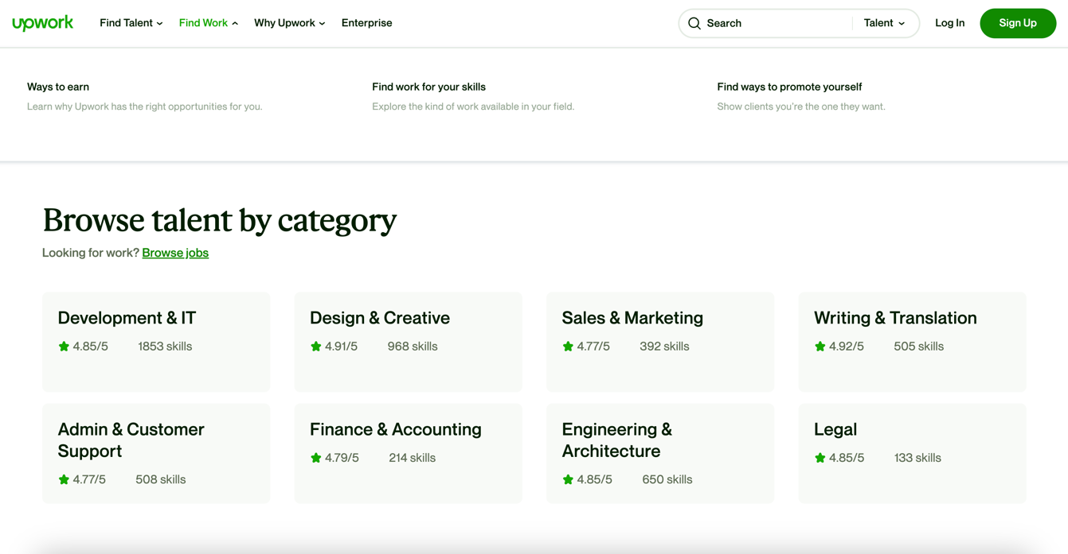

**Figure 2.2:** Upwork Search By Category Dashboard

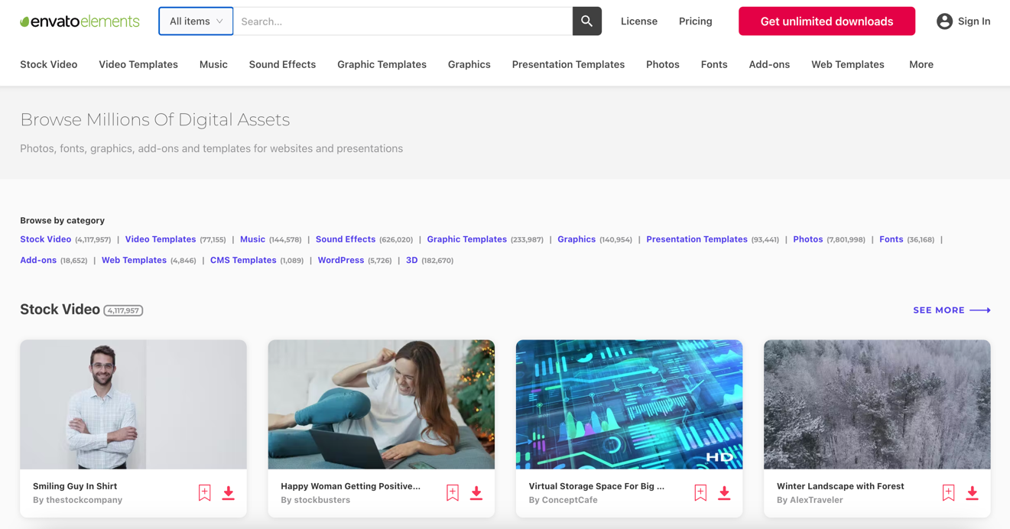

**Figure 2.3:** Envato Elements Resource Dashboard

## **2.1.1.1 Pros of Existing Systems**

* Fiverr offers a wide variety of services at different price points.
* All platforms have a mobile app for easy access.
* A large community of freelancers and clients
* Offers a huge library of digital assets including graphics, templates, video and audio files in envato elements
* Envato Element provides unlimited downloads for a single subscription fee.
* provides commercial licensing for all assets, making them suitable for use in client work.
* Fiverr and Upwork offers a messaging system and project management tools for efficient collaboration.

## **2.1.1.2 Cons of Existing System**

* Some freelancers may not have enough experience or expertise.
* Fees can be high for both the freelancer and the client.
* Limited communication options between buyer and seller
* Envato Elements has no opportunity for direct communication with sellers.
* Do not provide a single platform for both designers and resources.

## **2.1.1.3 Pros of the Proposed System Over Existing System**

* Our system offers a rating and review system to help ensure the quality and reliability of designers.
* We offer competitive pricing for both designers and buyers, with no additional service charge.
* Our system provides a real-time chat function for easy communication between buyers and sellers.
* Our system provides a single platform for both designers and resources, making it easier for buyers to find everything they need in one place.
* Our proposed system includes a whiteboard function that allows users to communicate in real-time and share their ideas visually.

**CHAPTER 3**

# METHODOLOGY

## **3.1 Overview of the Proposed System**

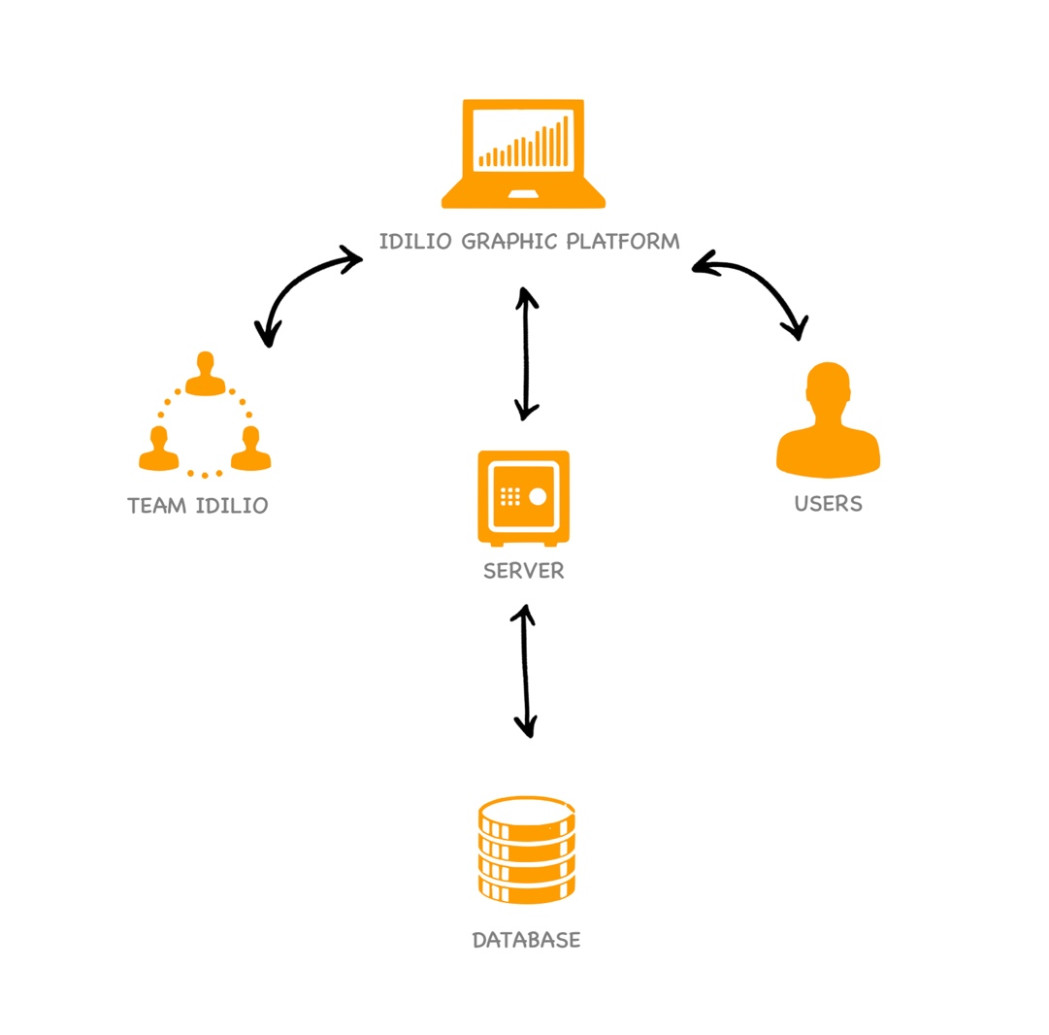Figure 3.1 shows the overview of the proposed system which indicates how the system interacts with all the stakeholders.

**Figure 3.1:** Overview of the Proposed System

## **3.2 Requirement Analysis**

### **3.2.1 Requirement Of The System**

#### **3.2.1.1 Software Requirement Specification**

Software requirement gathering involves hardware, GUI interfaces and how they are useful to users, speed of operations, the response time of the system, probability of system via various platforms, maintainability, recoverability, security, etc.

There are two categories named functional requirements and non-functional requirements under requirement specification.

**3.2.1.1.1 Functional Requirements**

* Designer
  + Create an account in the system with the necessary details.
  + Log in to the system with valid credentials.
  + Create a designer profile with the necessary details.
  + Ability to update or delete the created profile.
  + Create resources with necessary details.
  + Ability to update or delete the created resource.
  + Ability to accept or decline orders from buyers.
  + Ability to access the requirement page and message the particular buyer.
  + Ability to order from the same system as a designer.
  + Ability to update, deactivate personal profile.
  + Ability to place orders for other sellers’ shops with the necessary details.
  + Ability to search resource by category, amount or project name.
  + Ability to upload current artwork frequently.
  + Ability to give feedback to another sellers for order.
  + Ability to cancel orders anytime.
  + Ability to view progress window for relevant orders in queue.
* Buyer
* Create an account in the system with the necessary details.
* Log in to the system with valid credentials.
* Ability to search resource by category, amount, or project name.
* Ability to place orders for resource design and new design on one platform.
* Ability to view feedbacks for resources.
* Ability to view order progress according to the orders’ status.
* Ability to update submitted drawing.
* Ability to message designers with IDILIO live chat.
* Ability to complete order and give feedback to designer.
* Ability to select predefined packages from new design page.
* Ability to update, deactivate personal profile.
* Ability to cancel orders anytime.
* Ability to submit multiple files for design requirement.
* Ability to do their payment via PayPal gateway and credit card

#### **3.2.1.1.2 Non-Functional Requirements**

* Users must have email and password credentials for login.
* Users must have to access the application through the internet via a web browser.
* Searching, inserting, retrieval of data from database using easy button clicks and user-friendly interfaces.
* Better security.
* Should have easy maintainability.
* Should have easy understandability of the system to the buyers and sellers.

### **3.2.2 Use Case**

A use case diagram (Figure 3.2) in the Unified Modeling Language (UML) is a type of behavioral diagram defined by and created from a Use-case analysis. Its purpose is to present the graphical overview of the functionality provided by a system in terms of actors, their goals (represented as use cases), and any dependencies between those use cases.

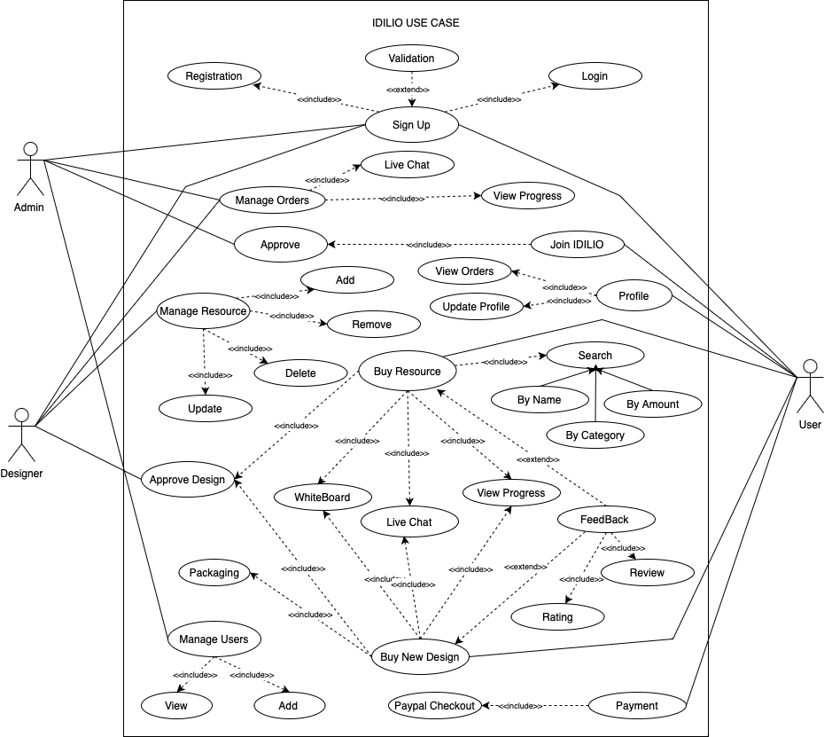

**Figure 3.2:** Entity Relationship Diagram

## **3.3 Design**

### **3.3.1 Entity Relationship Diagram**

Admin

An ER diagram (Entity Relationship Diagram) represents the logical structure of database of the proposed system. Figure 3.3 shows the ER diagram of the proposed system.

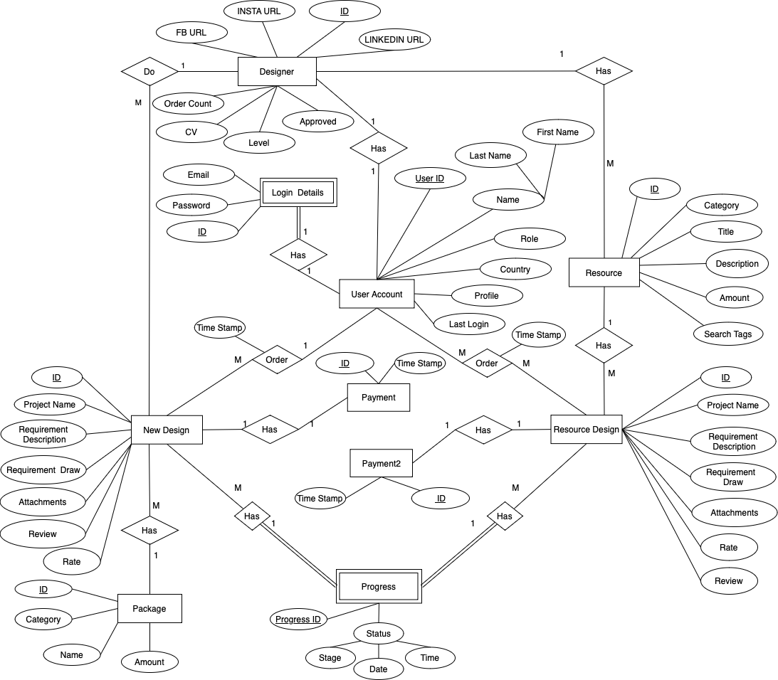

**Figure 3.3:** Entity Relationship Diagram

### **3.3.2 Domain Modeling**

#### **3.3.2.1 Class Diagram**

Class diagrams are one of the most useful types of diagrams in UML as they clearly map out the structure of a particular system by modeling its classes, attributes, operations, and relationships between objects. Figure 3.4 shows the class diagram of the proposed system.

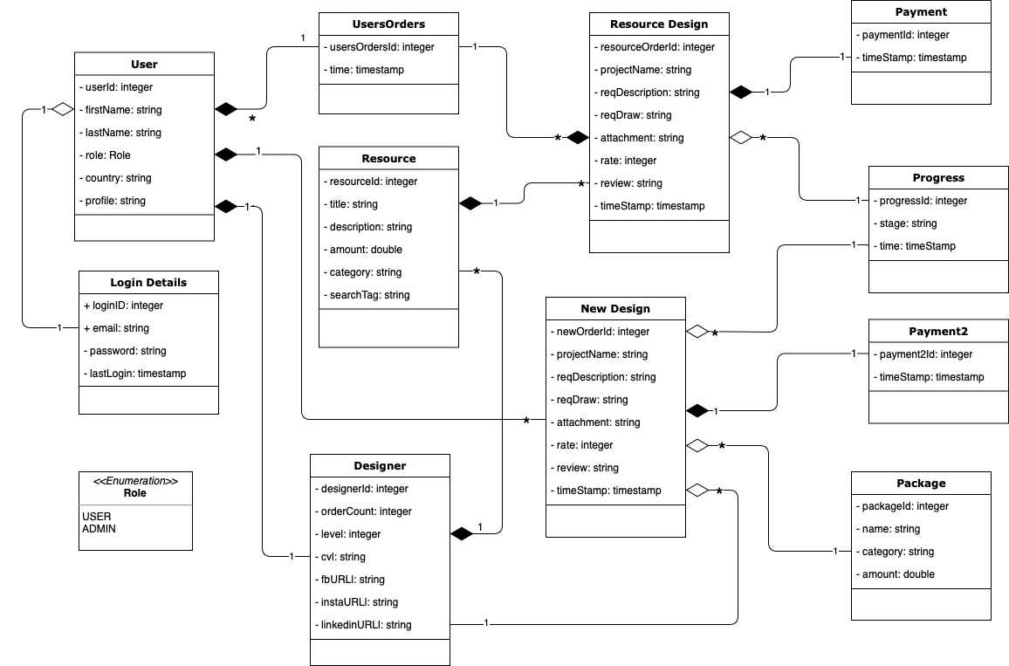

**Figure 3.4:** Class diagram

## **3.4 System Modules**

1. Login
2. User Registration
3. Dashboard
4. Buyer dashboard
5. Designer dashboard
6. Admin dashboard
7. Add Resource
8. create/view/update/delete resource
9. Resource orders
10. place/update/view/delete orders
11. New Orders
    1. place/update/view/delete orders
12. Search
13. Search by resource title
14. Search by resource category
15. Search by amount
16. User Profile
17. Update user details and profiles
18. Delete user profiles
19. Join IDILIO

## **3.5 Tools and IDEs**

1. IntelliJ Idea CE
2. Visual Studio Code
3. MySQL workbench
4. Postman

## **3.6 Development Environment**

1. Hibernate ORM 6.1.6
2. Spring MVC
3. Apache Tomcat Web Server
4. Application Build Tool (Maven)
5. React TypeScript/ Tailwind CSS
6. Daisy UI 2.51.5

## **3.7 Testing Environment**

1. Operating systems: Mac OS Ventura 13.2
2. Web browser: Google Chrome, Safari
3. JRE 17
4. Back-End Development: Spring Boot 3.0.1
5. Database: MySQL 8.0.27
6. Apache Tomcat server version 8.
7. JavaScript Runtime Environment: Node.js 17.1.0
8. Front-End Development: React 18.2.0
9. Postman 10.12

**CHAPTER 4**

# RESULTS AND DISCUSSION

This chapter contains the results of the project and the snapshots for each of the activity with a brief description for each activity while describing how it works.

## **4.1 User Functionalities**

### **4.1.1 Signup-User Form**

Figure 4.1 shows the IDILIO registration page, where users can sign up for an account by providing their valid email, first name, last name, country, and a password that meets the specified requirements. The password must contain at least 6 characters, one uppercase letter, one lowercase letter, one number, and one special character. Additionally, users are required to agree to the terms and conditions before proceeding with their registration. Once all the required information has been provided and the terms and conditions have been agreed upon, the user can successfully register for an IDILIO account. Additionally, the page has an option to show the password for ease of use. After completing the registration process, each user will be assigned a unique JSON web token that will serve as their identification within the platform.

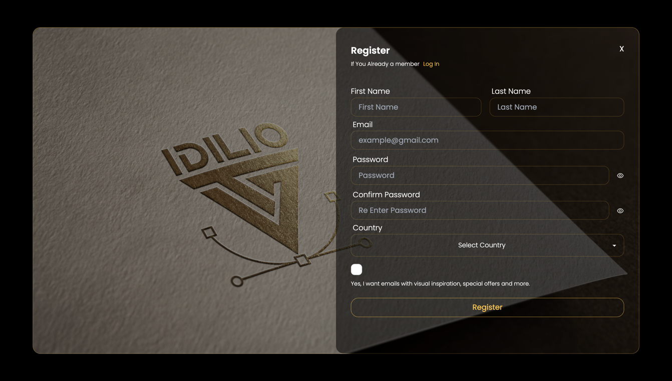

**Figure 4.1:** Registration form

### **4.1.2 Login Form**

Figure 4.2 shows the login page that sellers and buyers can log in to the system with the username and password they provided on the signup. If they are successfully login into the system, they will auto direct to the overview page. Each time you log in, the application checks the validity of your token to ensure that only authorized users can access the system.

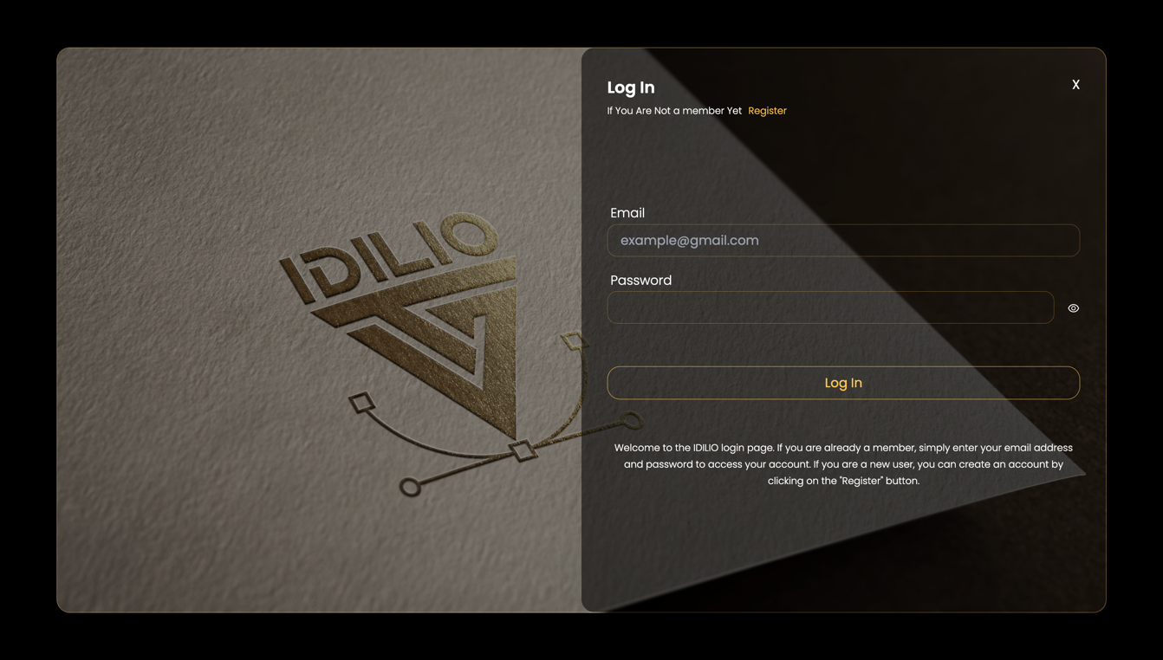

**Figure 4.2:** Login form

### **4.1.3 Home Page**

Figure 4.3 is the IDILIO home page that displays the featured art, followed by the navigation to the new order page and resource order page after clicking the "Discover" button. Users can also view site reviews and feedback to attract new users. Additionally, there is a "Join IDILIO" section specifically for freelancers to join the platform. Furthermore, the featured art section on the home page is designed to showcase the best work available on the platform, providing users with a glimpse of the quality of work they can expect from IDILIO. This section helps create a positive first impression and encourages users to explore 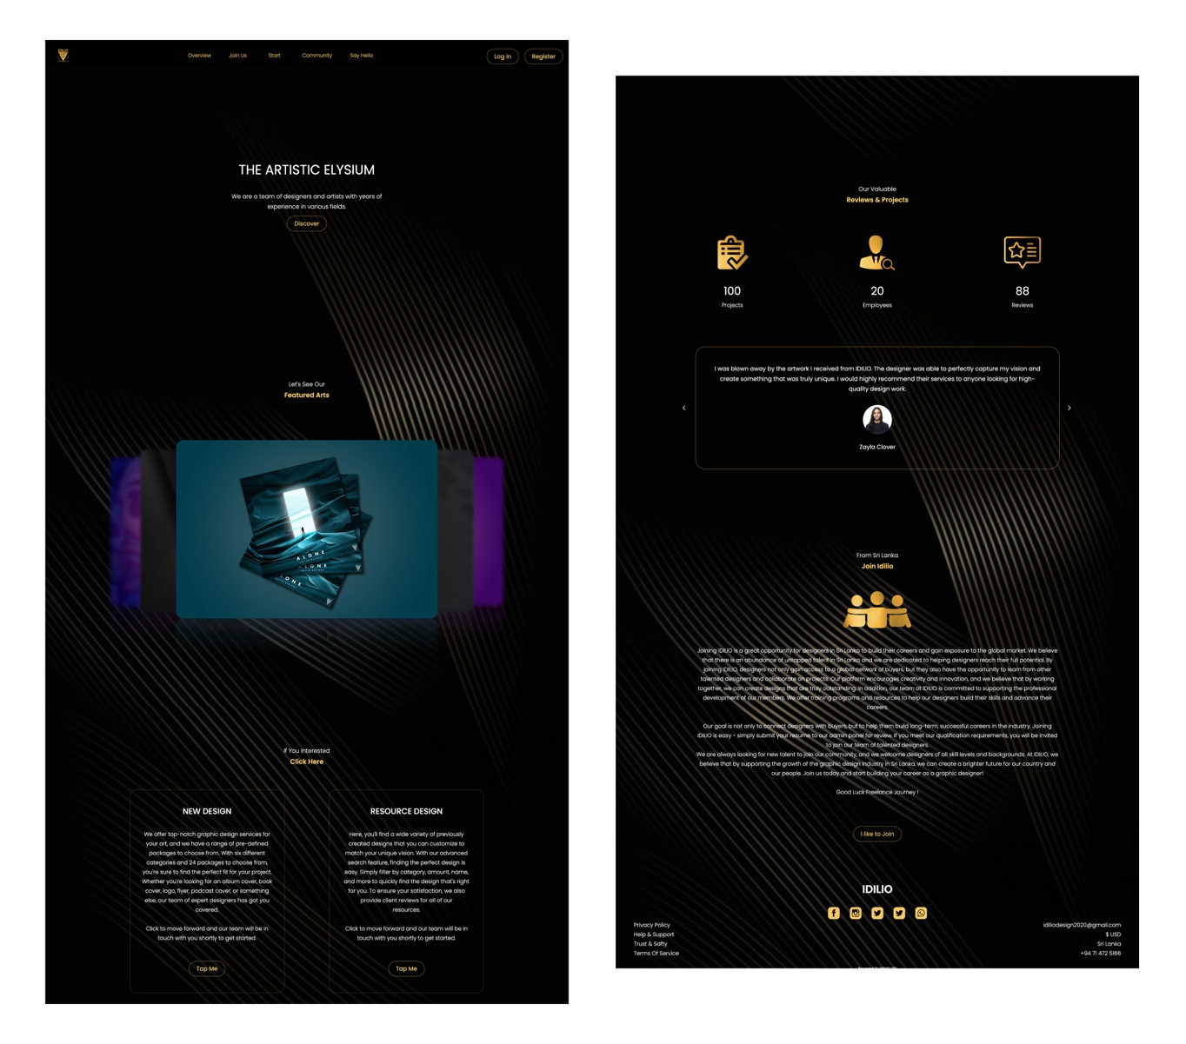the platform further.

**Figure 4.3:** Home page

### **4.1.4 New Order Page**

The IDILIO New Order Page (Figure 4.4) offers users a variety of options to choose from, with six different categories available: album covers, podcast covers, book covers, mascot logos, flyers, and company logos. Within each category, there are four different packages to select from, resulting in a total of 24 packages to choose from. Each package offers a different set of features and pricing to suit the user's specific needs. Once the user has selected a package, they can proceed to the requirements page by clicking on the "Order Now" button. This page serves as a platform for the user to provide specific requirements and details about their project to the freelancer.

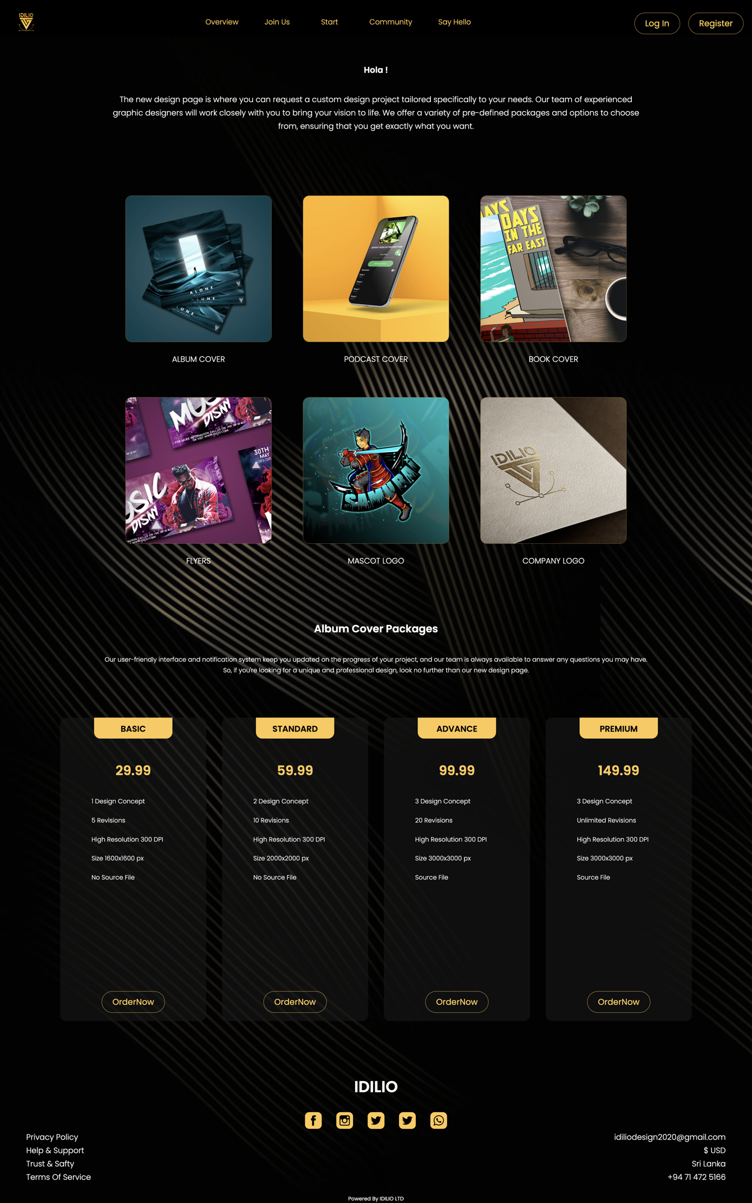

**Figure 4.4:** Shop Details Page

### **4.1.5 Resource Order Page**

The IDILIO resource order page(Figure 4.5) allows users to browse through pre-created artworks by designers within the IDILIO platform. Users can use the advanced search option to search for artworks by title, cost, and category. Each artwork is displayed in a resource order card, where users can view the title, amount, category. By clicking on a resource order card, users are redirected to the art detail page to view more information about the artwork.

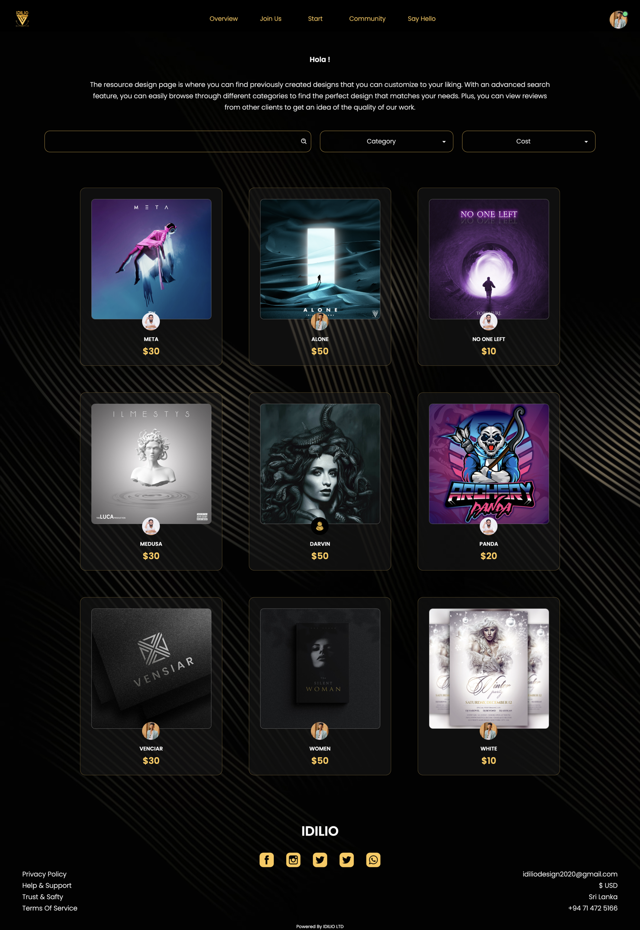

**Figure 4.5:** Resource Order Page

### **4.1.6 Resource Design Details Page**

The IDILIO resource design details page (Figure 4.6) provides users with all the necessary information about the resource design, including the title, a description of the design, and the designer's name. Users can also find an "Order Now" button on the page that redirects them to the order page to purchase the design. However, if the user is the designer of the design, the button will not be displayed to ensure that designers cannot purchase their own designs for fake customer reviews. The page also features a feedback section, where users provide feedback on past orders.

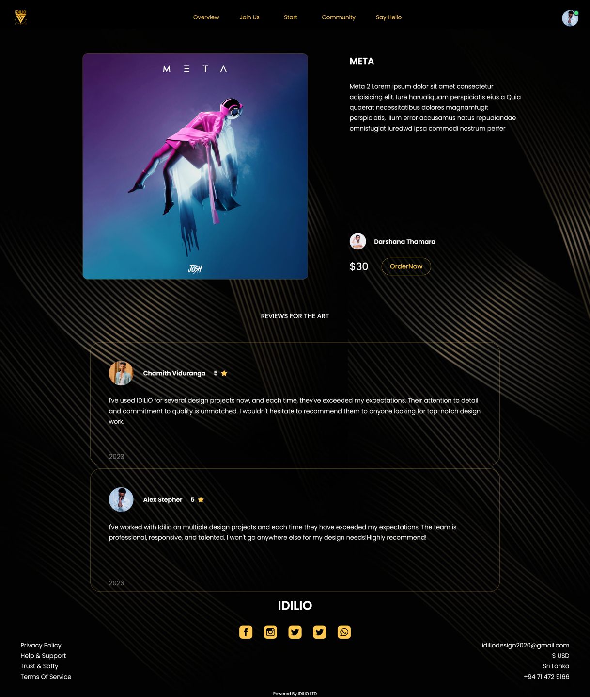

**Figure 4.6:** Resource Design Detail Page

### **4.1.7 Requirement Page**

The requirement page(Figure 4.7), (Figure 4.8) in IDILIO is where buyers provide detailed information about their design needs. For a new design order, the page displays the package number, category, and package name for the buyers to confirm. In the case of a resource order, the page additionally shows the resource art, designer, and cost. The other input fields are the same for both types of orders, including the project name, requirement description, whiteboard drawing, and attachments for design.

The whiteboard drawing feature is particularly useful for overcoming language barriers, allowing buyers to visually communicate their design requirements to designers. The page also includes a reset button for clearing the drawing.

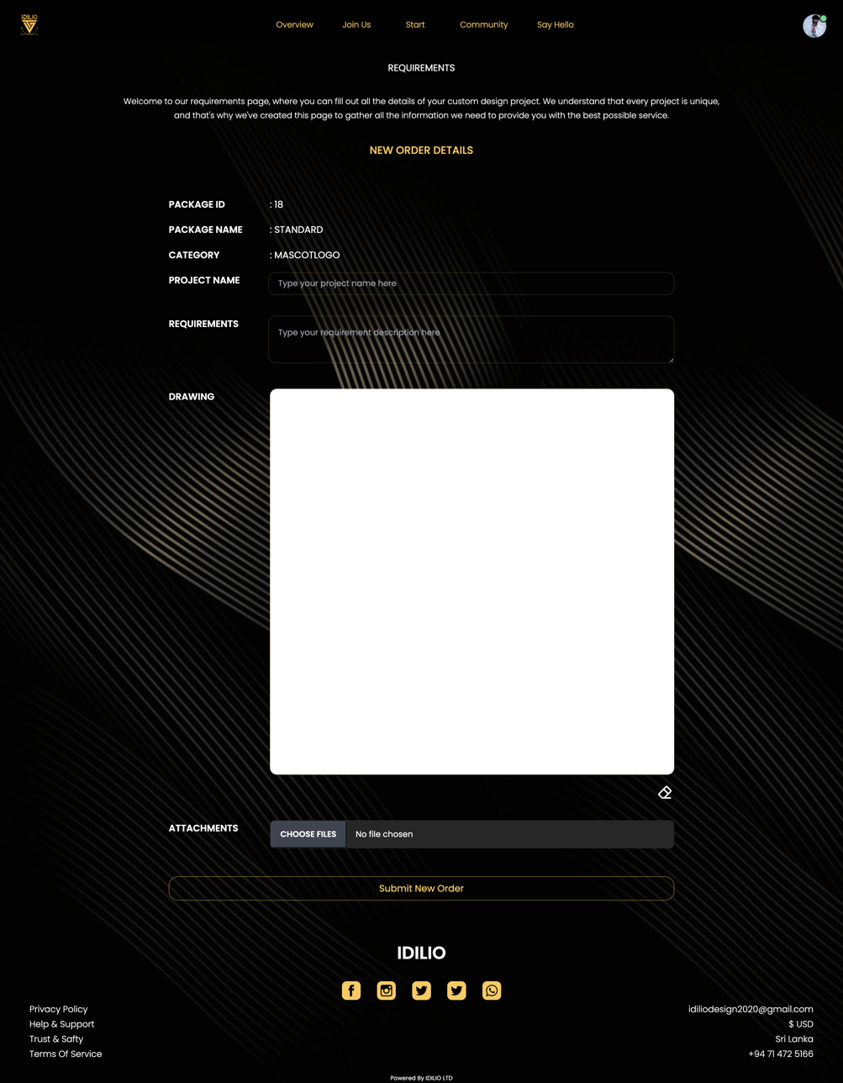Once the buyer has provided all the necessary information, they can submit the form, which redirects them to the progress page, where they can track the status of their order with all the details they provided.

**Figure 4.7:** New Order Requirement Page

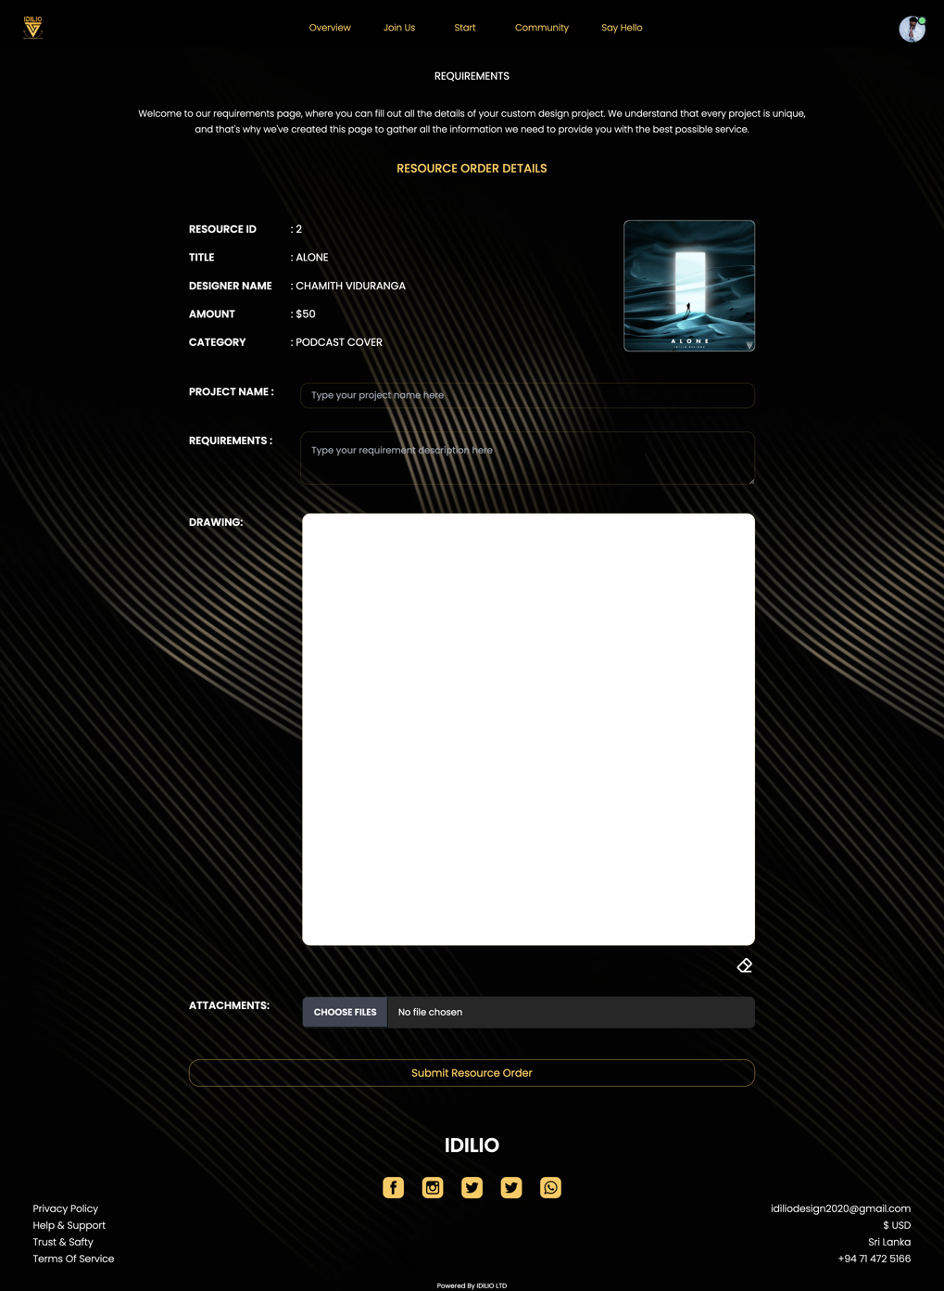

**Figure 4.8:** Resource Order Requirement Page

### **4.1.8 Progress Page**

The progress page in IDILIO contains four main sections. The first section displays the design requirements and details that were submitted by the buyer on the requirements page. The second section is the compare section, and the third section is the button section, which contains buttons for navigating to different modals in the IDILIO platform. The final section is the rating section, where buyers can rate and provide feedback on the selected design proposal.

#### **4.1.8.1 Order Details**

The "Order Details" section(Figure 4.9) inside the progress page provides a comprehensive overview of the buyer's order and requirements. It includes information such as the name of the designer, the cost of the design, and any attachments provided by the buyer. All the requirements mentioned on the requirements page are also listed here. This section allows the designer to have a complete understanding of the buyer's expectations and requirements.

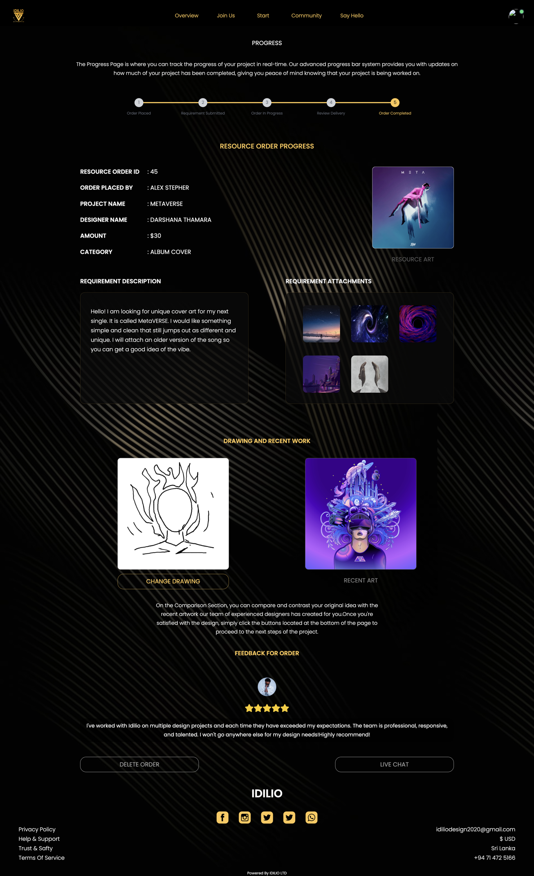

**Figure 4.9:** Order Details Section in progress page

#### **4.1.8.2 Compare Section**

Figure 4.10 depicts the "Compare" section of the Progress page on the IDILIO platform. This section is a useful tool for clients to compare the progress of their order against the original reference provided and to determine if the design is meeting their expectations. The Compare section allows for conditional rendering, which means that if the logged-in user is the client, they can make changes to their original drawing, and if the user is the designer, they can upload their most recent art multiple times to show the progress of the design. This feature ensures that both parties are able to effectively communicate and collaborate throughout the design process, leading to a higher-quality end result.



**Figure 4.10:** Compare Section in progress page

#### **4.1.8.3 Button Section**

The button section (Figure 4.11) in the progress page provides options for both clients and sellers to proceed to the next step, delete the order, or use live chat services. The buttons dynamically change based on the current step and the user's role. If the logged-in user is a client or seller, the buttons will adapt to each step of the progress page. In the 4th step, once the client accepts the order, a modal window will open for payment processing. In the 5th step, the middle button will disappear, and a feedback section (Figure 4.12) will appear for the client to provide their input.

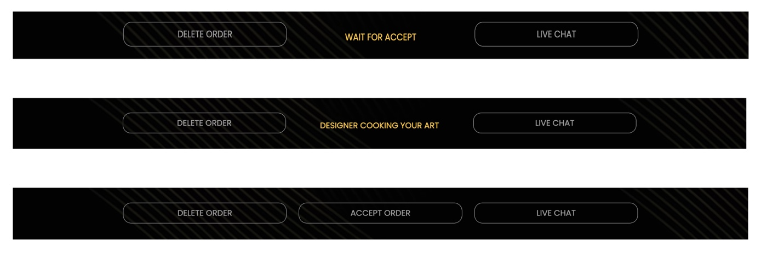

**Figure 4.11:** Button Section in progress page

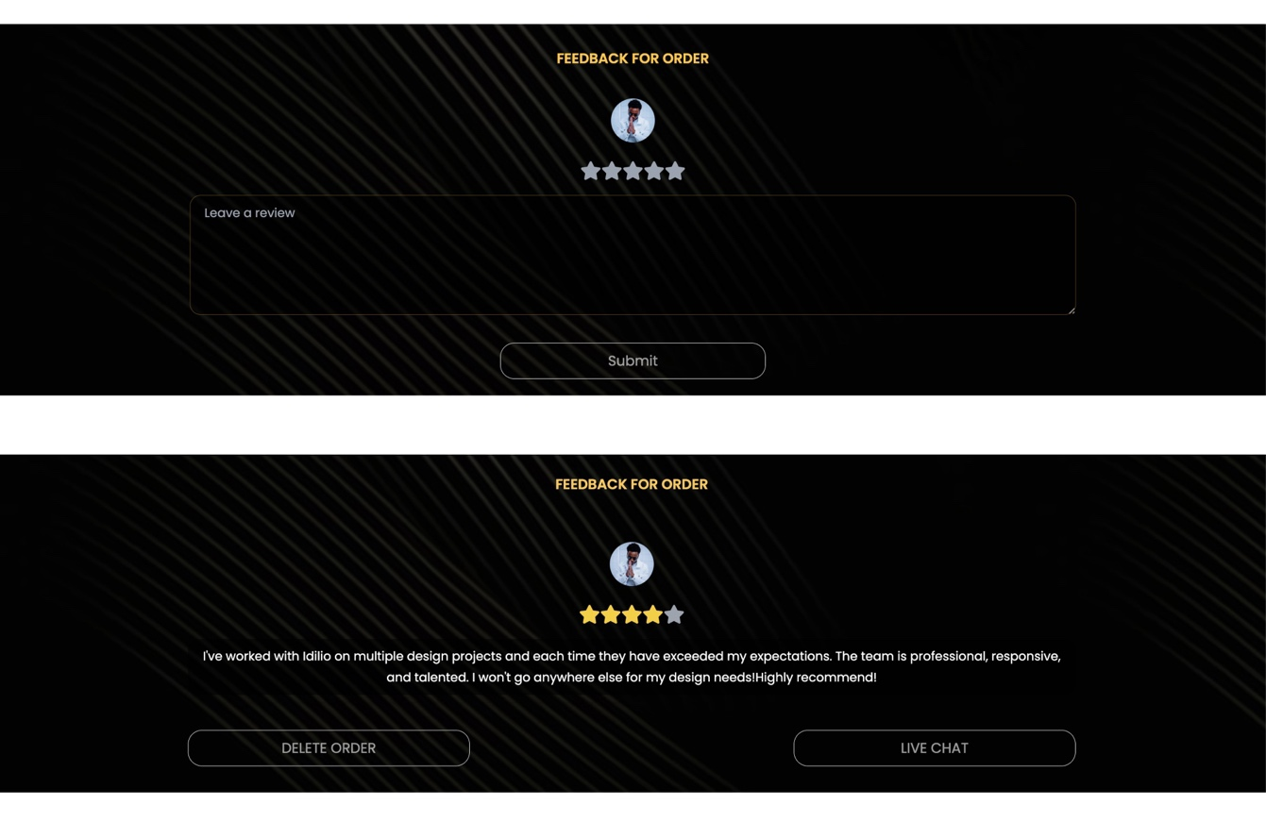

**Figure 4.12:** Feedback Section in progress page

#### **4.1.8.3.1 Delete Order**

The "Delete Order" section is a feature that allows users to delete their order in case of any inconvenience. When a user clicks on the "Delete order" button, a modal popup appears, asking for the project name to confirm the deletion of the order. This feature provides an easy and convenient way for users to cancel their order if they change their mind or face any issues with the design process.

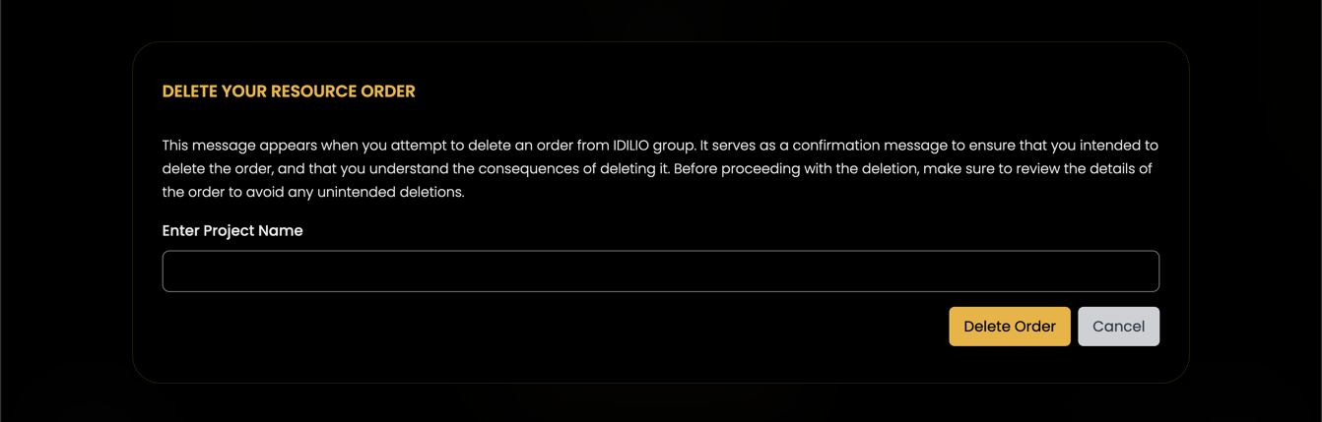

**Figure 4.13:** Delete Order - Pop-up Window

#### **4.1.8.3.2 Live Chat**

The IDILIO live chat service is a feature that allows users to communicate with the IDILIO graphic design platform in real-time. This feature is powered by chatengine.io, and it allows users to click on the live chat option, which will then display a chat bubble. If the user clicks on the chat bubble, it will open a chat sign-up window(Figure 4.14) where they can enter their email to chat with the IDILIO team.

The live chat service is designed to make it easy for users to get in touch with the IDILIO team quickly and efficiently. The platform's admin is responsible for responding to user inquiries and can do so through the admin dashboard. This feature helps users get their questions answered in a timely manner and allows the IDILIO team to provide top-quality support to its users.­

­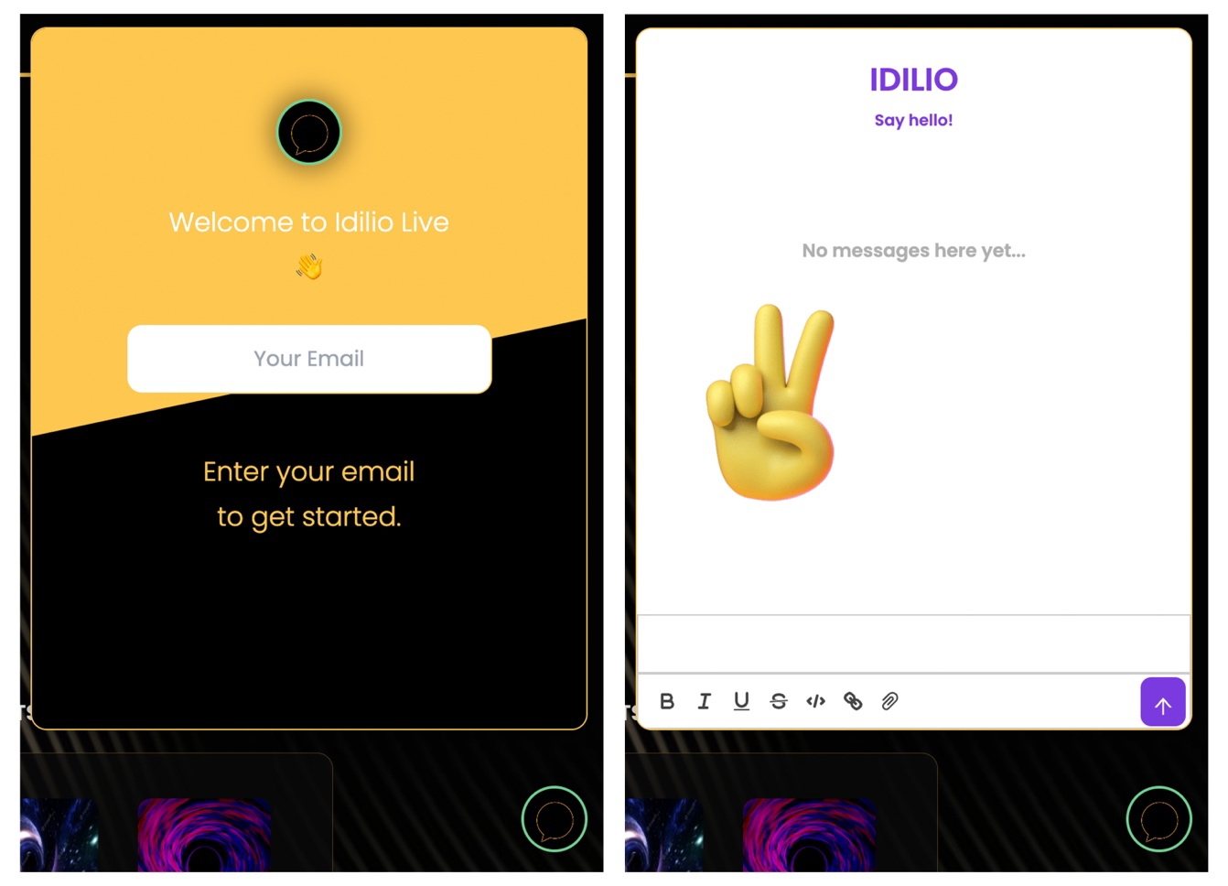

**Figure 4.14:** Live Chat - Pop-up Window

#### **4.1.8.3.3 Payment Modal**

The payment modal is a pop-up window(Figure 4.15) that appears when the client clicks on the "Accept Order" button in step 4 of the progress page. This modal allows the client to review the order details and confirm the payment amount. Once the client clicks on the "Pay Now" button, they will be redirected to the PayPal checkout page, where they can complete the payment using their PayPal account or credit/debit card information. The PayPal sandbox account is used for testing purposes to ensure the payment process works smoothly before going live.

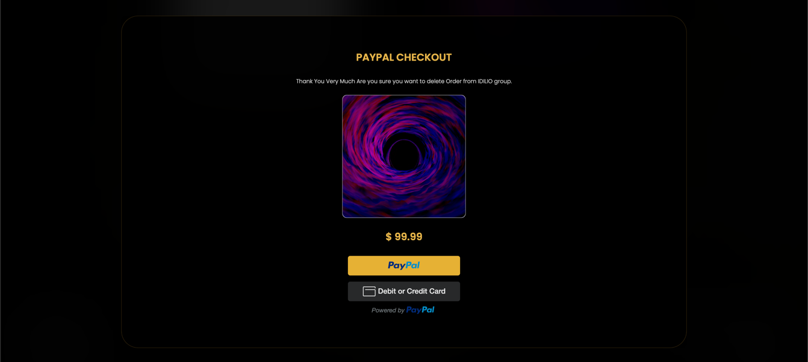

**Figure 4.15:** Payment - Pop-up Window

### **4.1.9 User Profiles**

#### **4.1.9.1 Client Profile**

The client profile page (Figure 4.16) is accessible to every user upon logging into the system. It includes a "Placed Order" section, which allows for easy navigation to the progress page of each order placed by the user. The lower section of the page displays the "Completed Order" section, which enables users to review their previous orders.

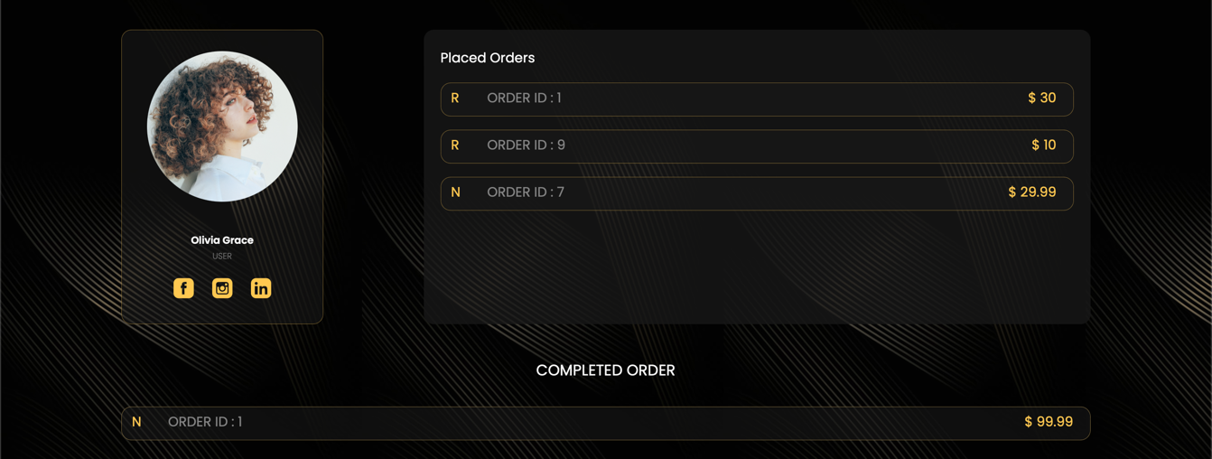

**Figure 4.16:** Client Profile

#### **4.1.9.2 Designer Profile**

The designer profile page(Figure 4.17) contains several sections, including a profile card that displays the designer's personal information and portfolio. The order queue section displays all of the orders that the designer has received, and the placed order queue section displays the orders that the designer has placed. The new order queue section shows the new orders that the designer has received, and the my resources section displays all of the resources that the designer has created. Finally, the completed order section displays all of the designer's completed orders.

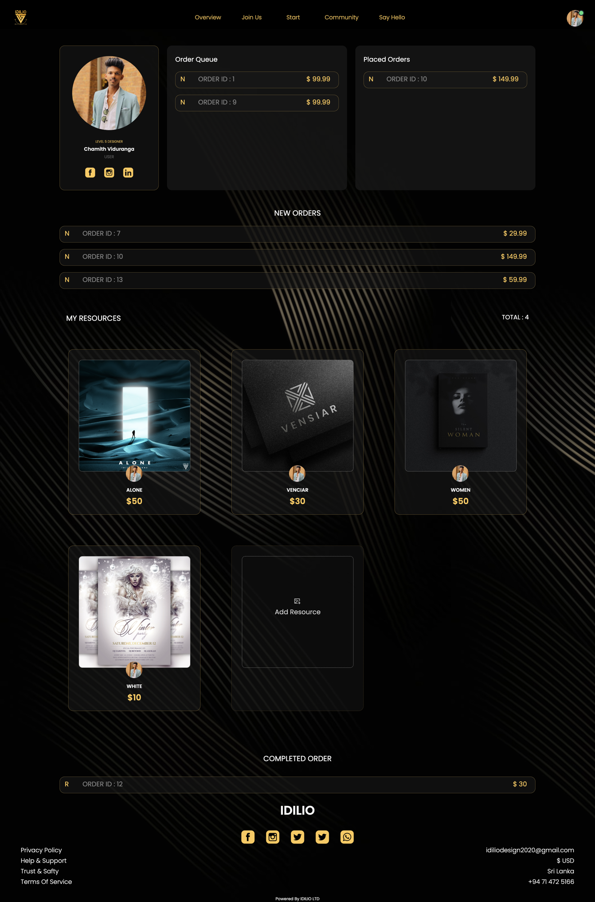

**Figure 4.17:** Designer Profile

#### **4.1.9.2.1 Order Queue**

The Order Queue section is available only to approved sellers approved by Idilio admins. It displays the ongoing orders with clients, which are in progress (steps 3-5). It shows both new orders and resource orders, which can be identified by R and N, respectively. When a card is clicked, it redirects to the progress page of the order.

#### **4.1.9.2.2 New Order Queue**

The new order section in the designer profile displays the orders that clients have just placed. These orders are indicated with green borders to make them easily identifiable. All designers in Idilio have access to this section and can review the requirements. If they are interested and capable of completing the design, they can accept the order and start working on it.

#### **4.1.9.2.3 Add Resource**

The Add Resource section is a feature for designers to upload their stunning art to the system. It consists of two main sections: the resource details section and the image upload area. The resource details section allows designers to input details such as the resource name, category, search tags, and cost. The image upload area allows designers to upload the actual resource image. This feature is accessed through a modal where designers can add and submit their resources for use in future design projects.Figure(4.18) shows how it works.

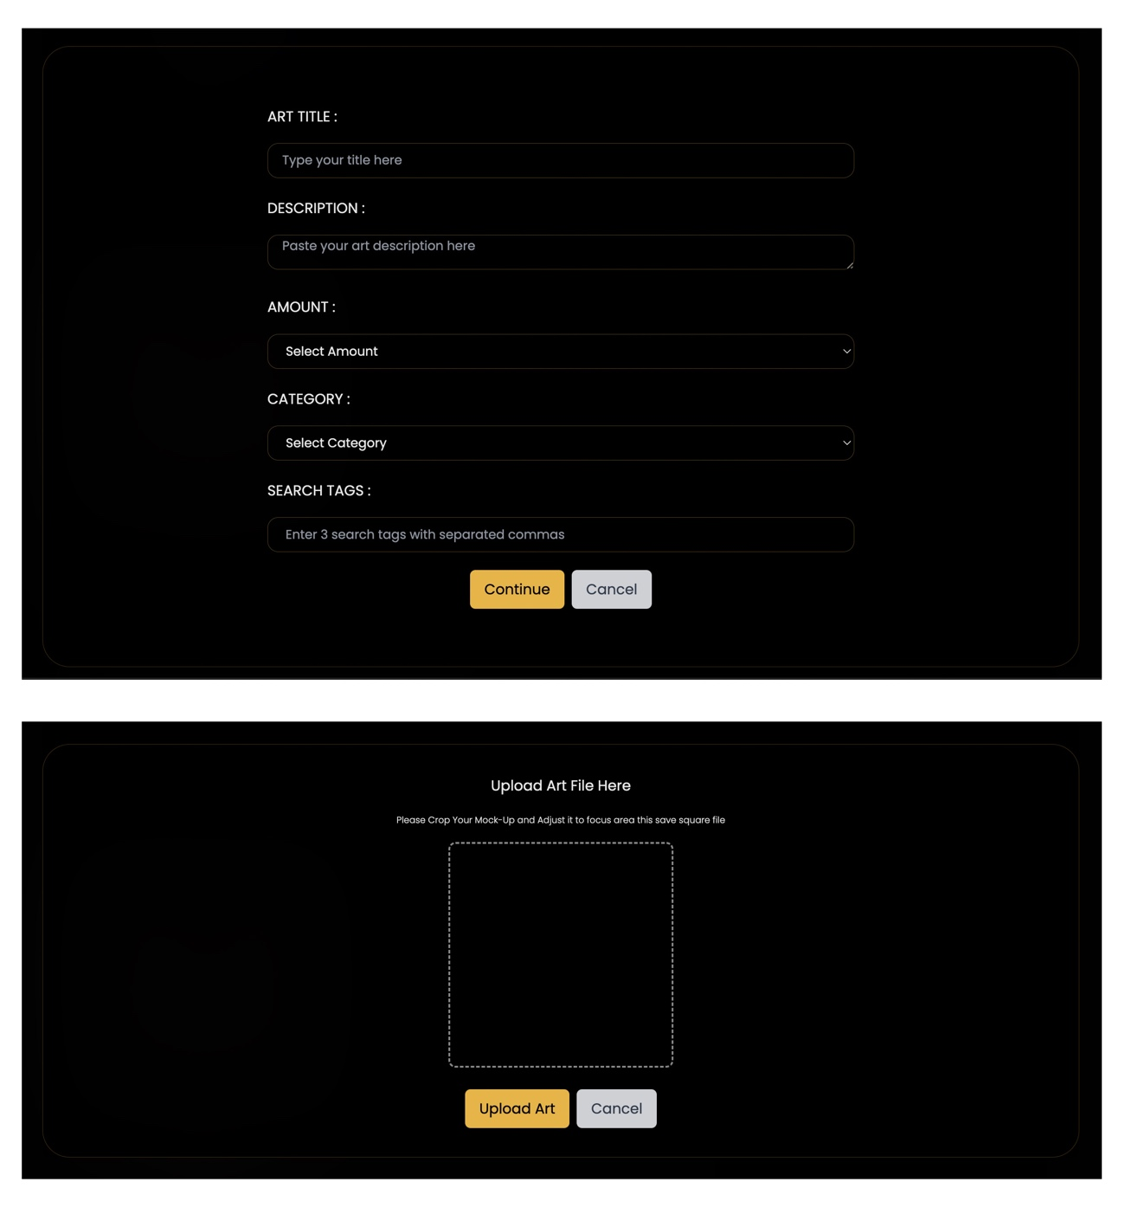

**Figure 4.18:** Add Resource Modal

#### **4.1.9.2.4 Update Resource**

The update design modal(Figure 4.19) is a pop-up window that appears when a designer clicks on a previously uploaded design. It displays three buttons for delete, update, and cancel update, allowing the designer to update the resource art if necessary. This feature enables designers to improve their resources over time and ensures that clients receive high-quality designs.

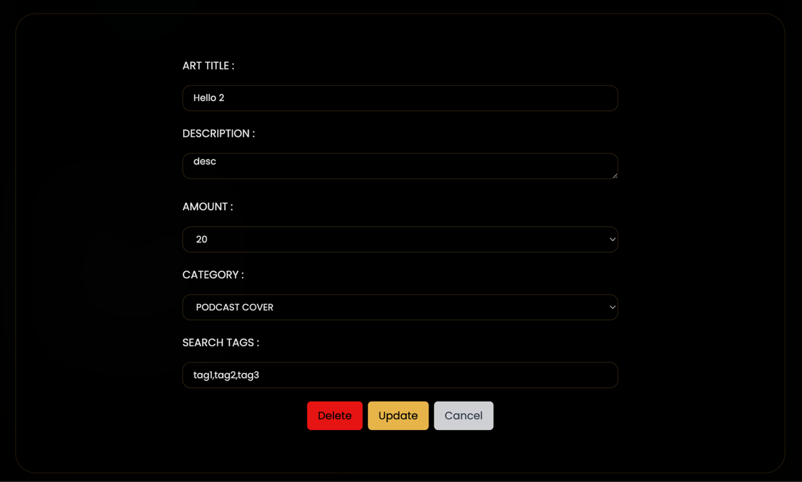

**Figure 4.19:** Update Resource Modal

#### **4.1.9.3 Profile Setup**

The profile setup section (Figure 4.20) is accessible through the navigation bar for both sellers and buyers. Once clicked, users are redirected to this section, where they can update their profile picture, first name, and last name. For designers, they have the option to update their social media links as well.

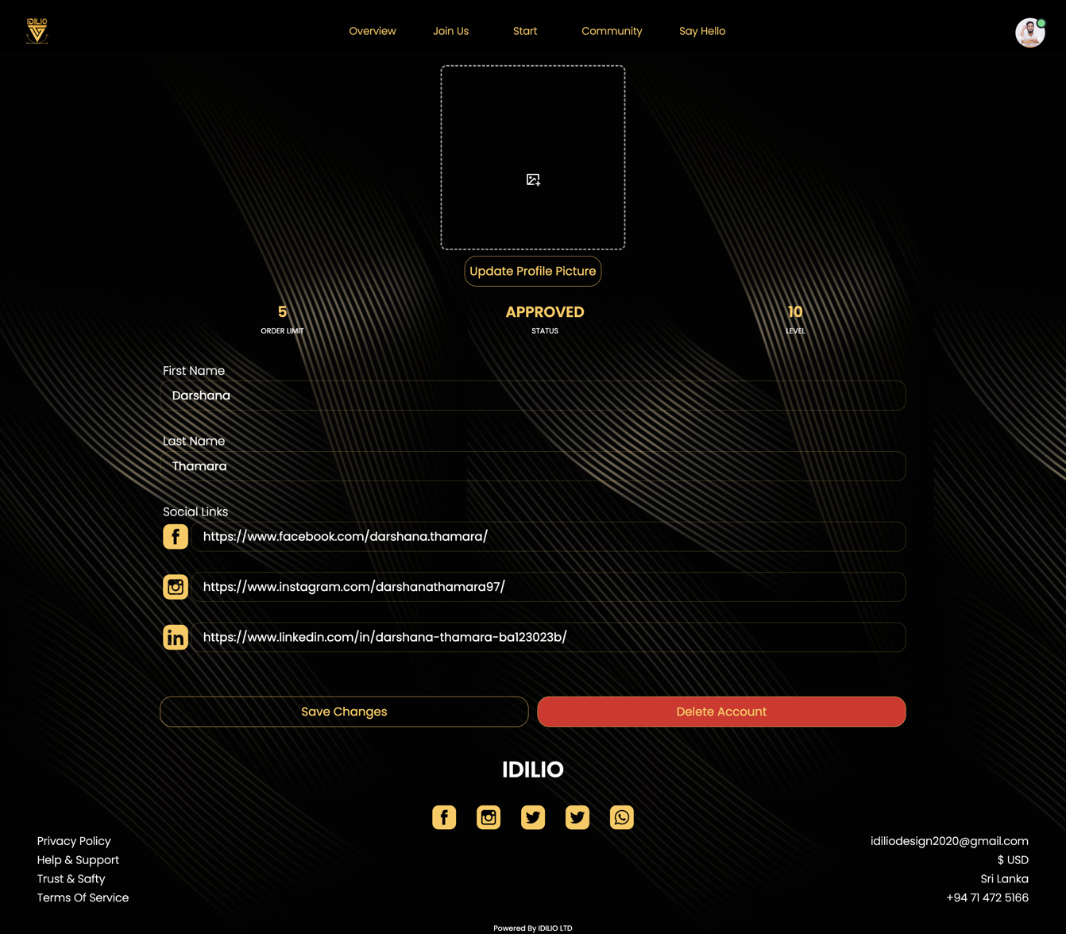

**Figure 4.20:** Profile Setup

#### **4.1.9.3.1 Delete Account**

The delete account modal(Figure 4.21) is available for all users. To delete their account, users must enter their first name correctly in the provided field. Once confirmed, the user account will be deleted, and they will be automatically logged out of the system.

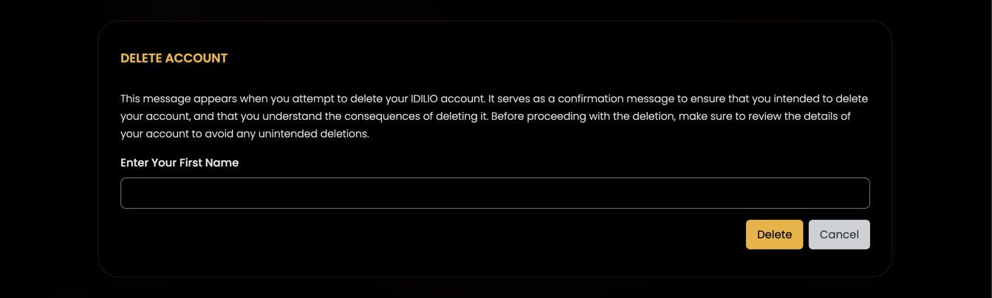

**Figure 4.21:** Delete Account Modal

### **4.1.10 Admin Dashboard**

The admin dashboard section(Figure 4.22) contains several features, including a section for approving new designers. Admins can view each designer's LinkedIn profile and contact them through the platform to verify their authenticity. After conducting interviews with potential designers, admins can click the "Accept" button to approve them. The approved designers are then added to the "Approved Designers" section.

In addition to approving designers, the admin dashboard also shows all the new orders received by the platform. Admins can view the orders at any time and provide support to clients and designers through the live chat service.

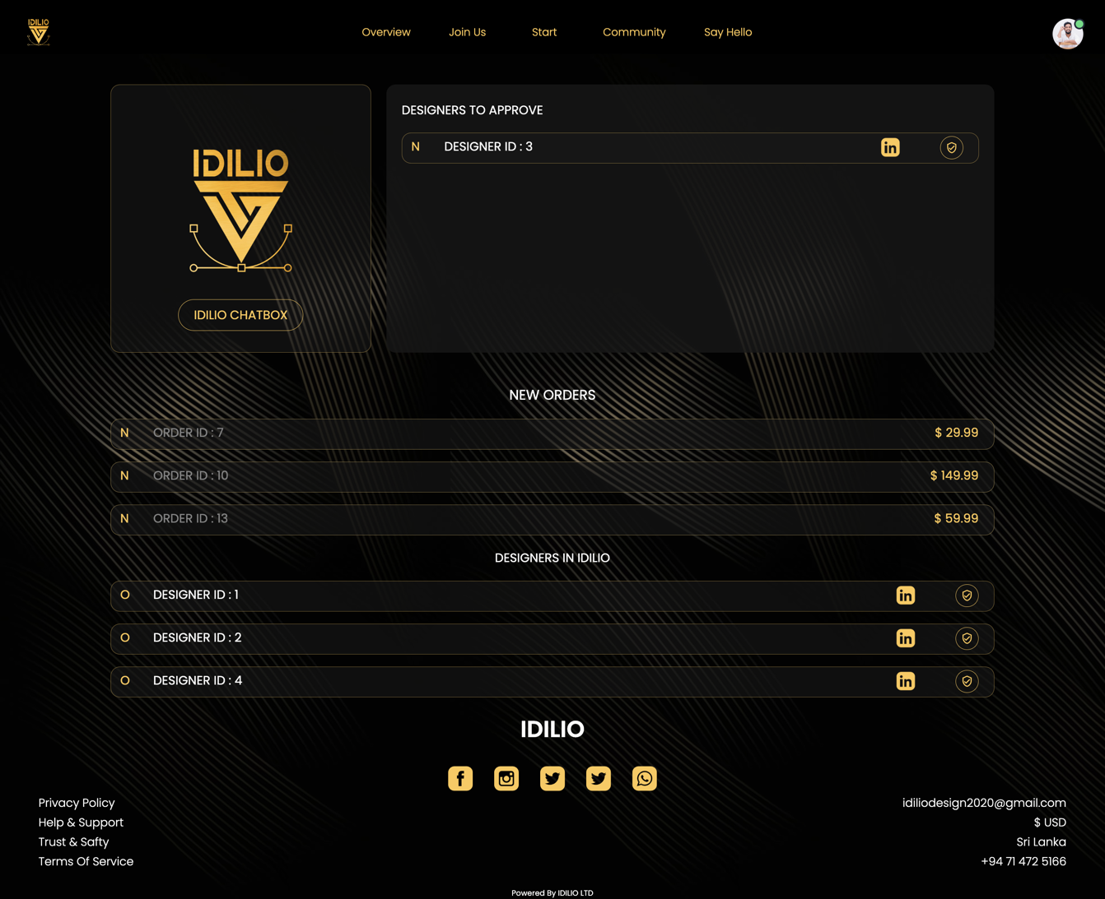

**Figure 4.22:** Admin Dashboard

### **4.1.11 Join IDILIO**

The Join Idilio section is exclusively available for users in Sri Lanka who are interested in starting their freelancing journey with Idilio. Users can submit their application through this section, and designers will view their LinkedIn profile and conduct an interview to determine if they are a good fit for the Idilio graphic design team. Once the user is selected, they can start working with Idilio on various design projects.



**Figure 4.23:** Join IDILIO Form

**CHAPTER 5**

# CONCLUSIONS AND RECOMMENDATION

## **5.1 Conclusions**

The Idilio Graphic Design Platform offers a streamlined and efficient way for clients to connect with talented designers and get their design projects completed in a timely manner. The platform's intuitive interface, easy-to-use features, and secure payment system make it a reliable choice for both clients and designers. By bringing the entire design process online, Idilio eliminates the need for manual intervention and offers a more effective and profitable way for designers to showcase their work and for clients to get their design needs met. With its user-friendly interface and comprehensive features, Idilio is a game-changer in the world of graphic design.

## **5.2 Recommendation**

The current system already includes some security measures, but there is always room for improvement. It is recommended to add additional security features such as two-factor authentication, encryption of sensitive data, and regular security audits to ensure the system is protected against cyber-attacks.

In addition, the payment handling system can be further improved by providing more payment options, such as mobile payment systems and online banking. This will make the payment process more convenient for Sri Lankan users and encourage more people to use the system.

**CHAPTER 6**

# FUTURE WORKS

* Adding more functionalities for the admin dashboard
* Adding a countdown for all orders to track the time left for delivery
* Integrating social login for the system to improve user experience
* Adding more functions to the whiteboard to enhance collaboration
* Integrate a private chat feature for relevant orders for better communication between buyers and sellers.
* Adding an attachment section for further updates on orders, such as additional design elements or revisions.

# TIME PLAN

|  |  |  |  |  |  |  |  |  |  |  |
| --- | --- | --- | --- | --- | --- | --- | --- | --- | --- | --- |
| **Duration** | **01**  **Aug** | **15**  **Aug** | **01**  **Sep** | **15**  **Sep** | **01**  **Oct** | **15**  **Oct** | **01**  **Nov** | **01**  **Jan** | **01**  **Feb** | **15**  **Apr** |
| **Action** |
| Proposal and Requirement Analysis |  |  |  |  |  |  |  |  |  |  |
| Design |  |  |  |  |  |  |  |  |  |  |
| Implementation |  |  |  |  |  |  |  |  |  |  |
| Documentation |  |  |  |  |  |  |  |  |  |  |
| Testing and Debugging |  |  |  |  |  |  |  |  |  |  |

# REFERENCES

1. Stack Overflow Available at [https://stackoverflow.com](https://stackoverflow.com/) [Accessed on 05 January 2023]
2. YouTube Available at [www.youtube.com/](http://www.youtube.com/) [Accessed on 15 February 2022]
3. Tailwind Available at <https://tailwindcss.com/docs/installation> [Accessed on 10 September 2022]
4. TypeScript Available at <https://www.typescriptlang.org/docs/> [Accessed on 13 November 2022]
5. Spring Available at [www.spring.io](http://www.spring.io) [Accessed on 25 October 2022]
6. React Available at <https://legacy.reactjs.org/docs/getting-started.html>[Accessed on 20 August 2022]
7. Daisy UI Available at <https://daisyui.com/> [Accessed on 28 August 2022]